Assignment due: check eConestoga

Problem Specification: (Tic-Tac-Toe)

1. Create a Tic-Tac-Toe game in C#.
2. Use common controls for creating the game.
3. The game starts with an X.
4. If the game concludes with a winner show message.
5. If it is a “draw” show message also.
6. After ending the game, initialize the game so that another game can be played. Note: don’t use Application.Restart(). Initialize manually;

**Remember to incorporate the followings for all assignments (if applicable)**

* Add Header/Title comment.
* Add Documentation comment.
* Add Implementation comment where (you think) necessary.
* No magic number.
* You must use **images** for X and O. Load images through resources. Don’t use absolute path of images in your code.
* Align the controls to have a better look.

Note: Use your own imagination for designing the user interface. The snapshot of the Form is given only to clarify the requirement. You don’t have to make it exactly the same.

Hardcopy Submission Requirements (follow the sequence as stated)

1. Combined Cover page and Marking sheet.
2. Assignment 2 Marking sheet. (last page of this document)
3. Run your program, and then take a snapshot ( ALT+ PrtScn to printscreen your form).
4. Printout of your code. Print using Visual Studio 2013 IDE.
5. Make sure all Programming standards are followed. Read pages 12-40 for detailed information : [*http://www.conestogac.on.ca/cpa/common/handbook/Standards.pdf*](http://www.conestogac.on.ca/cpa/common/handbook/Standards.pdf)
6. Make sure all Assignment standards are followed.

Note: Repeated violation of the same standard is counted.

Softcopy Submission Requirements

1. Name the project as follows:

*FirstNameInitialLastName*Assignment*Assignmentnumber*

Replace *FirstNameInitial* and *LastName* based on your name. (Example: if the

students’ names are Jason Bourne, for Assignment 2, the name of the project

will be JBourneAssignment2) . Be careful about assignment number.

1. Make sure the entire solution is within the zip file, and also remember to fulfill the naming rule mentioned at point 1.
2. Log in to your D2L account.
3. Select the course PROG2370, your section and locate the Assignment’s dropbox.
4. Upload the zip file.

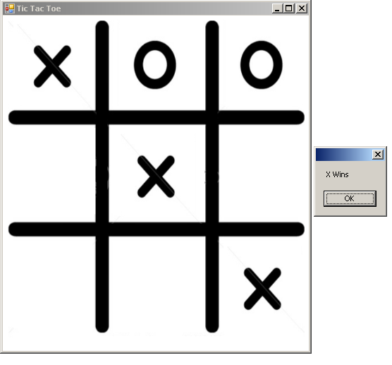Assignment 2 Marking Sheet

**Name:__________________________________________(please fill your name)**

|  |  |
| --- | --- |
| **Spec** | **Marks** |
| (Attractive/Colorful) User Interface Design | /20 |
| Game starts with an X | /10 |
| Game shows Winning message (e.g., X wins/O wins) at game end. | /25 |
| Game shows Draw message if there is no winner at game end | /15 |
| When one game completes, it initializes to starting – ready to be played again automatically. | /20 |
| X or O can only be placed in a free slot | /10 |
| **Total** | **____________/100** |

**Deduction:**

|  |  |
| --- | --- |
| Runtime errors | 15 x ____________ = |
| Assignment Standard | 5 x ____________ =________/20 |
| Programming Standard | 1 x ____________ =________/20 |
| Late Submission | 20 x_____________= |
| **Total Deduction** |  |

|  |  |
| --- | --- |
| **Total Marks** |  |